Data Analysis using Excel - Capstone Project

1. **Which company is making the highest profit - Black Cab or Red Cab?**

Ans: Red Cab has achieved the highest profit of 4,40,20,373

|  |  |  |  |
| --- | --- | --- | --- |
| **Row Labels** | **Sum of Price Charged** | **Sum of Cost of Trip** | **Sum of Profit** |
| Black Cab | 2,63,28,251 | 2,10,20,923 | 53,07,328 |
| Red Cab | 12,58,53,887 | 8,18,33,514 | 4,40,20,373 |
| **Grand Total** | **15,21,82,139** | **10,28,54,437** | **4,93,27,701** |

1. **Which company is performing well over a period, regardless of which year it is?**

Ans: The Red Cab company has demonstrated strong performance throughout the year 2017.

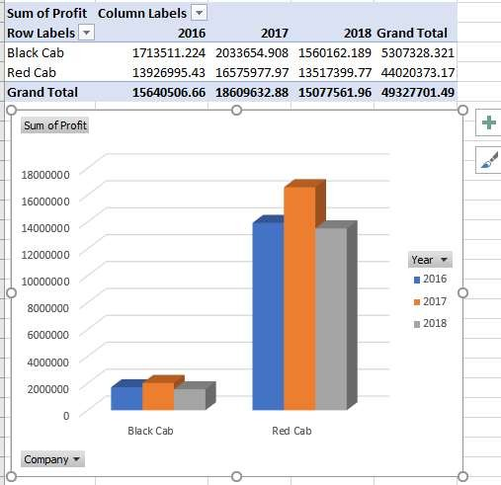

1. **Find the top 10 customers in terms of Income and identify the highest profitable customer.**

Ans: Here's the list of the top 10 customers ranked by income and profitability:

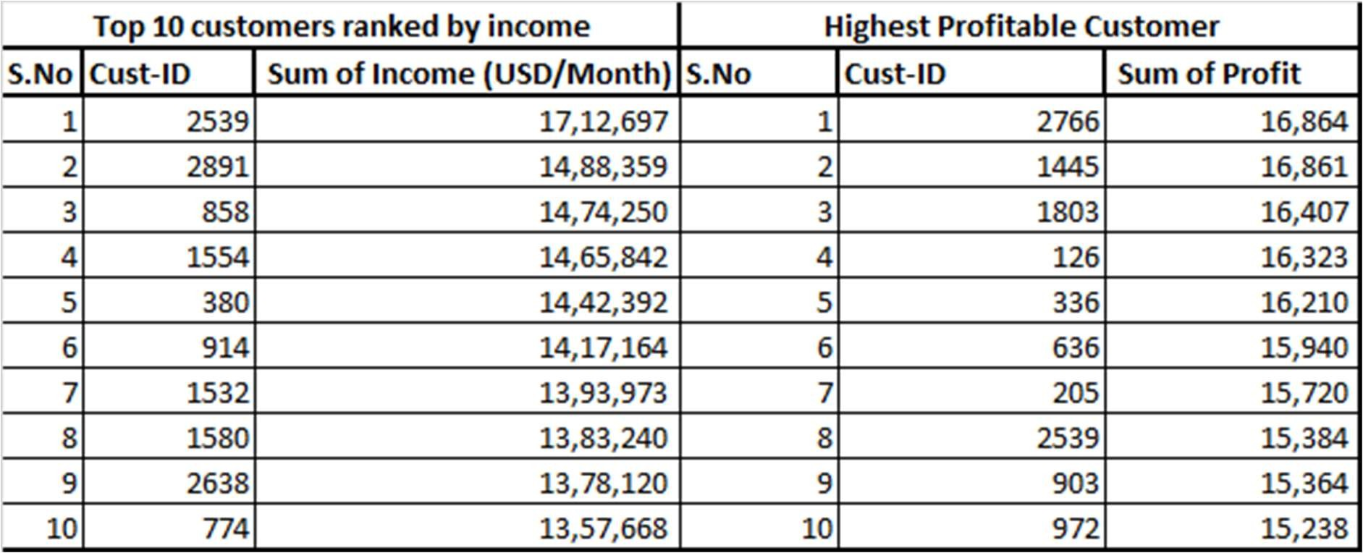

1. **Which gender (male or female) records the greater number of travels?**

Ans: Male customers have a higher number of travel records.

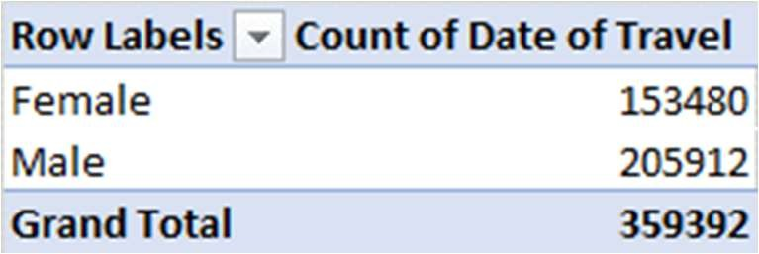

1. **Which income group has a greater number of travellers? Make this analysis dynamic by adding slicers.**

Ans: These three income groups comprise a larger number of travelers.

|  |  |  |
| --- | --- | --- |
| **S.No** | **Income (USD/month)** | **Count of Date of Travel** |
| 1 | 12000-16999 | 72099 |
| 2 | 17000-21999 | 70742 |
| 3 | 7000-11999 | 70510 |

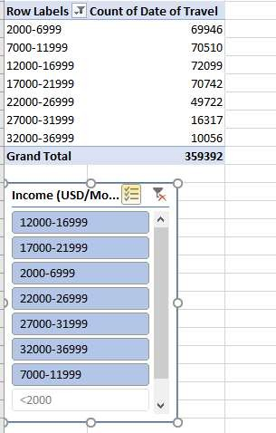Make this analysis dynamic by incorporating slicers for interactive filtering

.

1. **Did people prefer to pay by cash or card in Red Cab company in the year 2018?**

Ans: In 2018, there is a preference for payment by card among people.

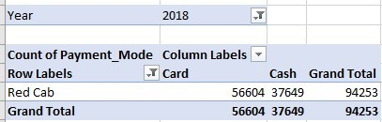

1. **Which age group has less willingness to travel on cabs?**

Ans: The willingness to travel by cabs among individuals in the 65 age group is comparatively lower.

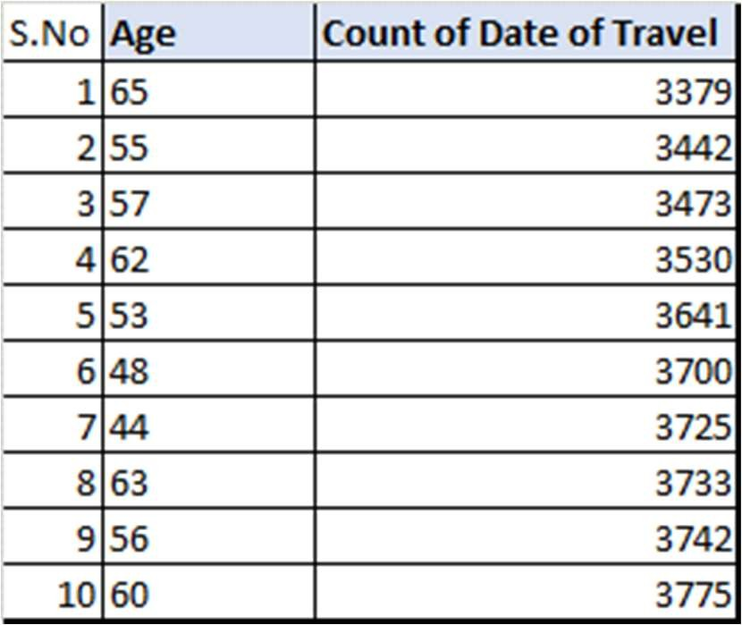

1. **Which gender, age group, and income group people travel more in the cab?**

Ans: Here's a breakdown of the demographic groups that are traveling more, categorized by gender, age group, and income group:

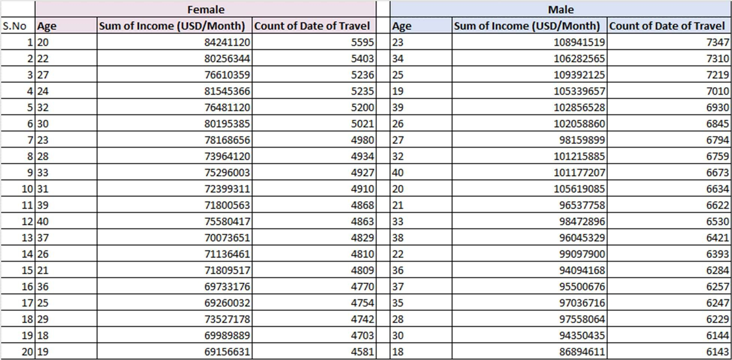

1. **Create a profitability dashboard across the demographics.**

